BIT4107 Final Portfolio

Technical Glossary
Flutter SDK:
Core development kit for cross-platform app development using Dart.
IDE:
Integrated Development Environment like VS Code used for coding, debugging, and project management.
CRUD:
Fundamental database operations: Create (add record), Read (view record), Update (modify record), Delete (remove record).
Routing:
The navigation framework that controls how a user moves between various screens (Login, Dashboard, Profile, etc.) within the application.
SQLite:
A local database engine embedded within the app for persistent data storage without requiring an internet connection.
Separation of Concerns:
Architectural pattern splitting the application into Models (data), Views (UI), and Services (logic/database) for maintainability.

Visual Evidence
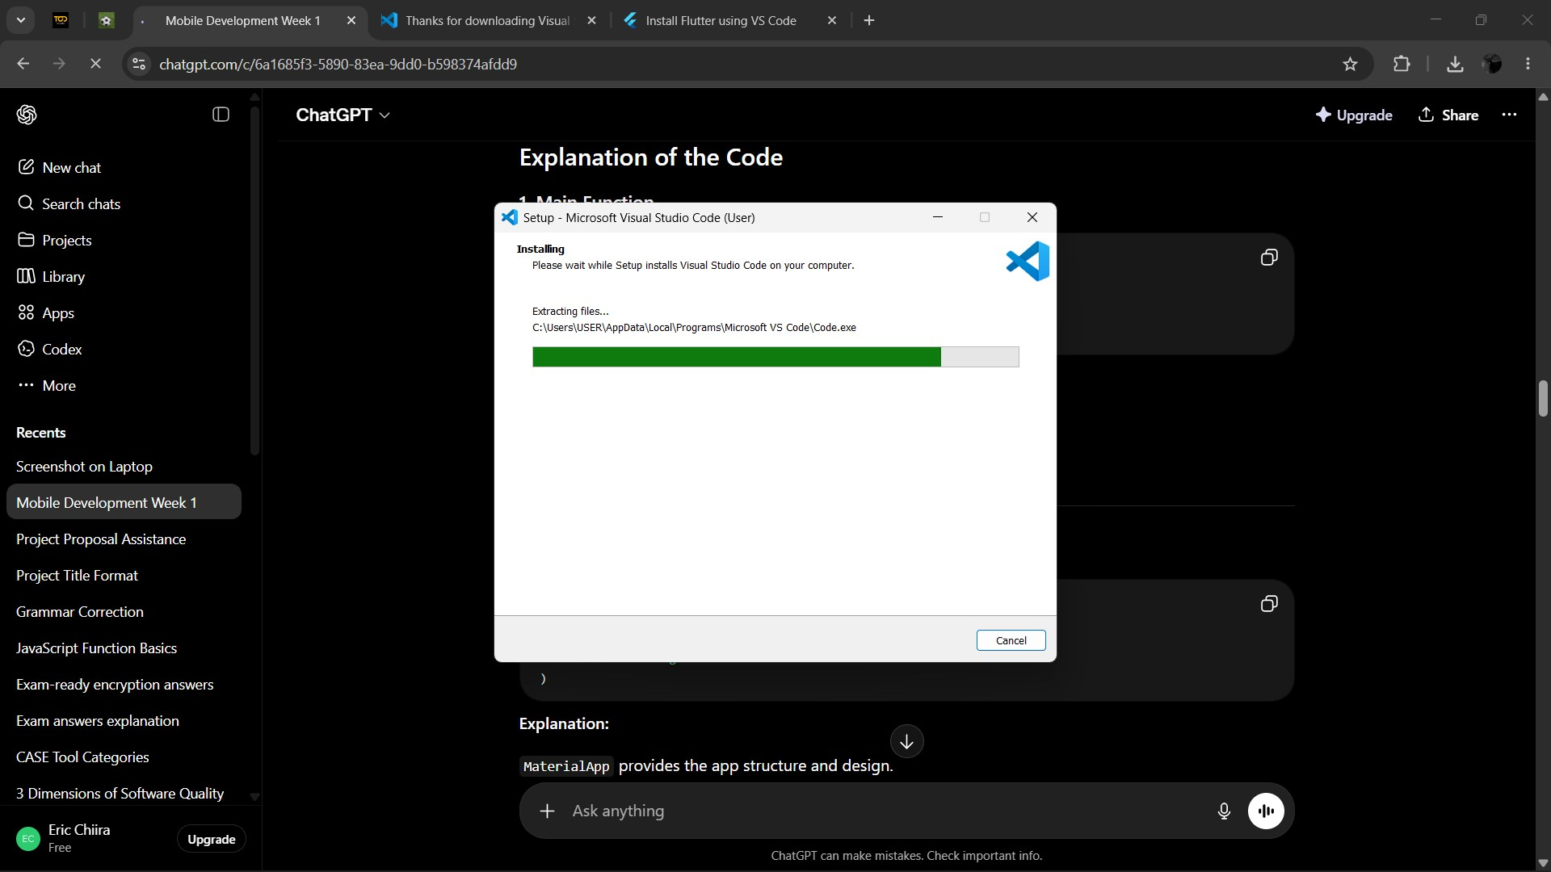
VS Code Installation Progress
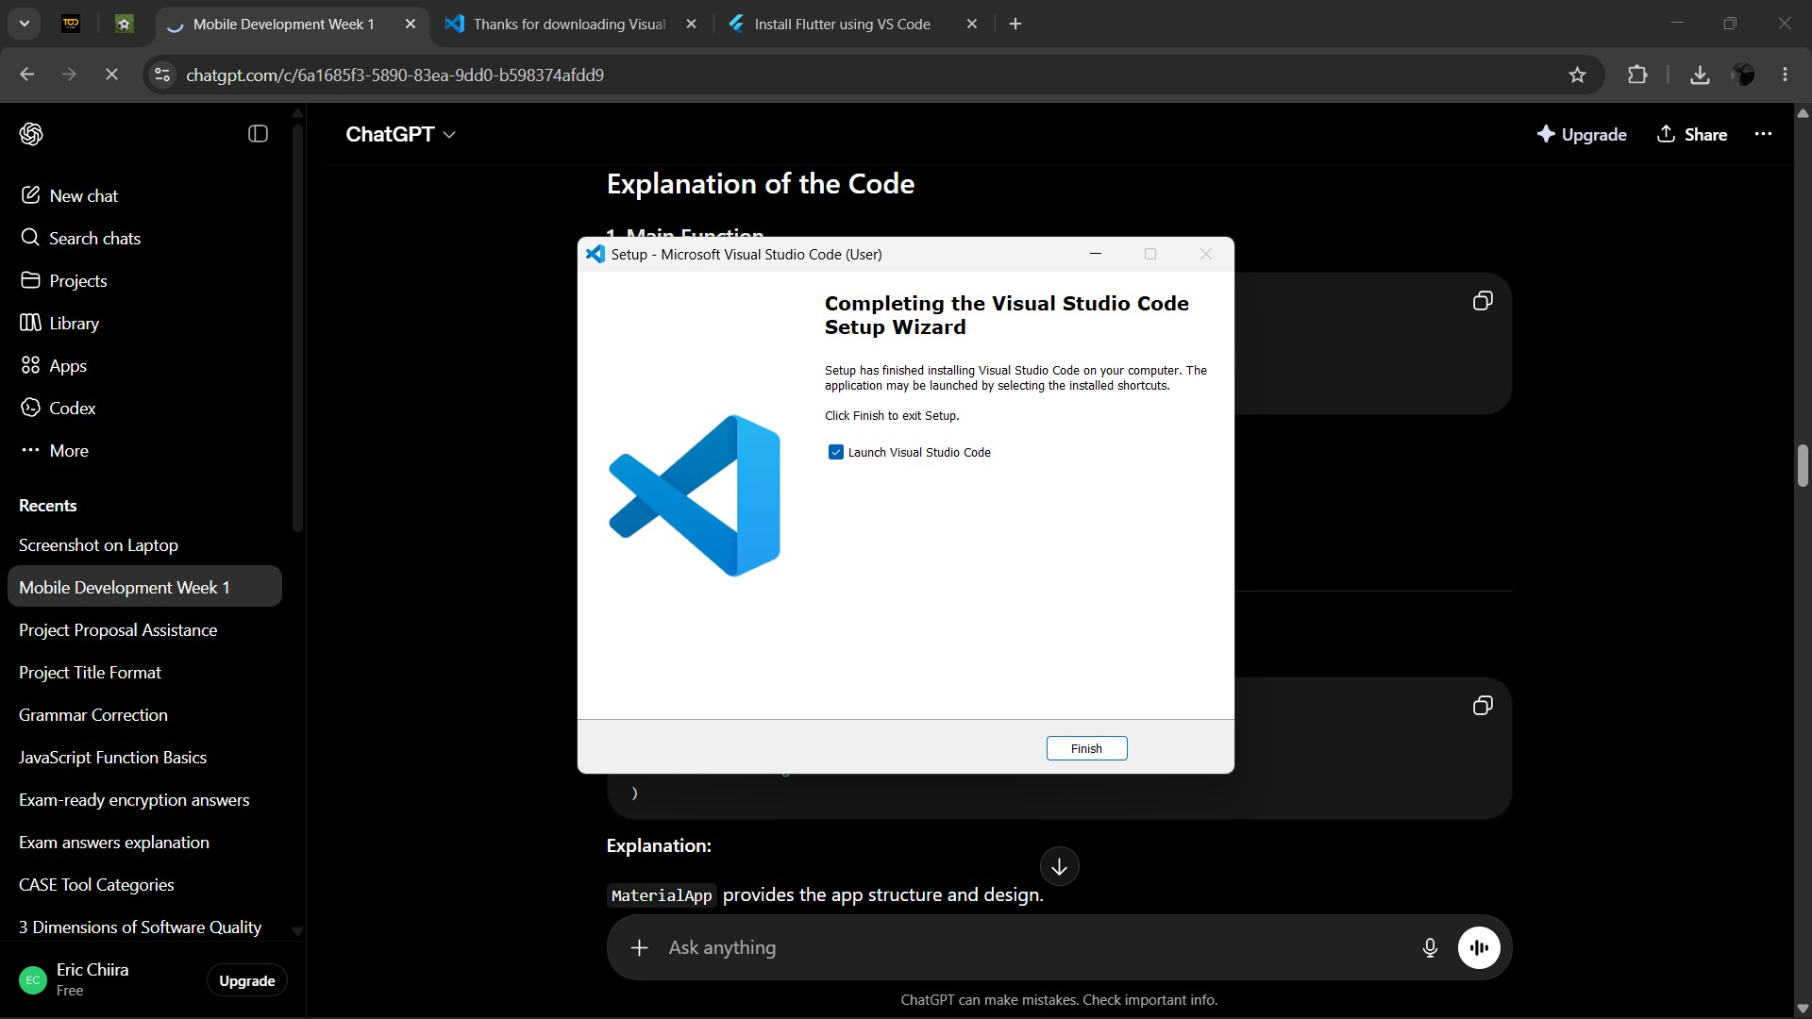
VS Code Setup Completion
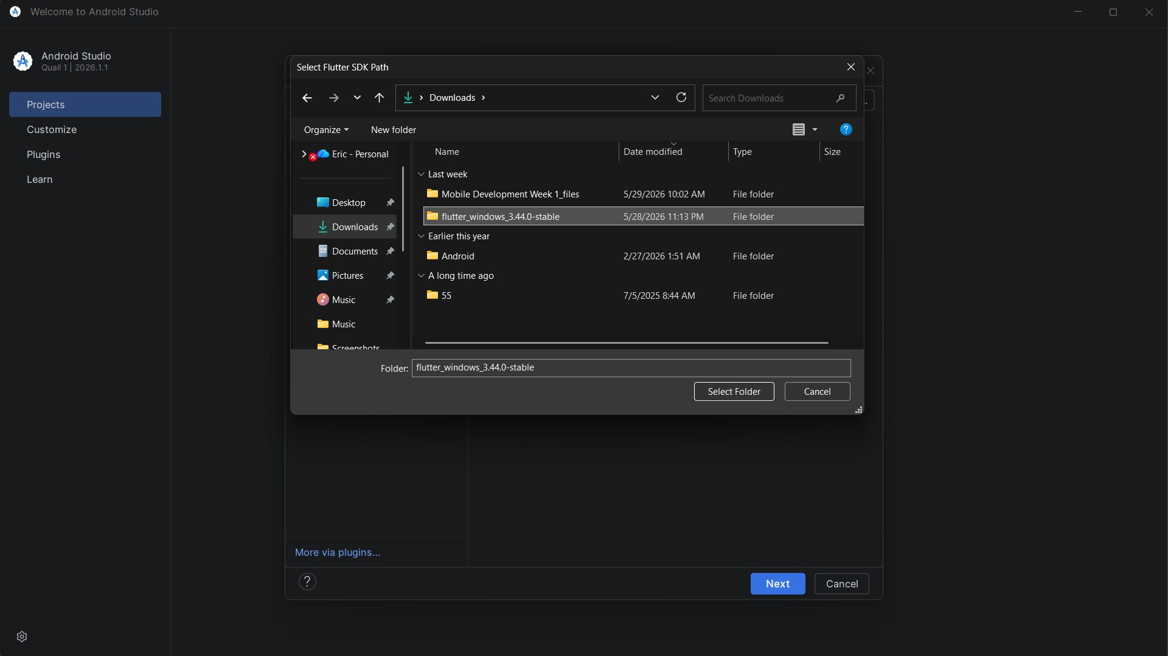
Configuring Flutter SDK Path in Android Studio
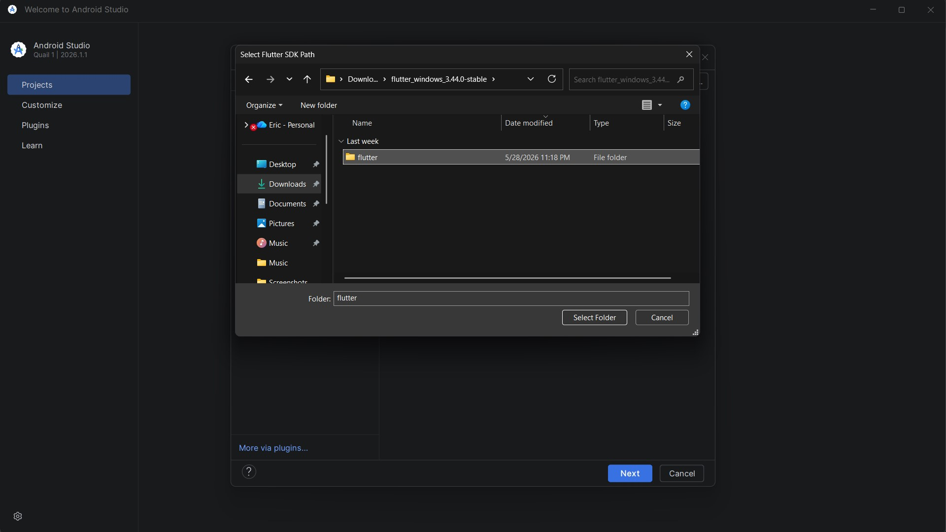
Selecting Flutter SDK Folder
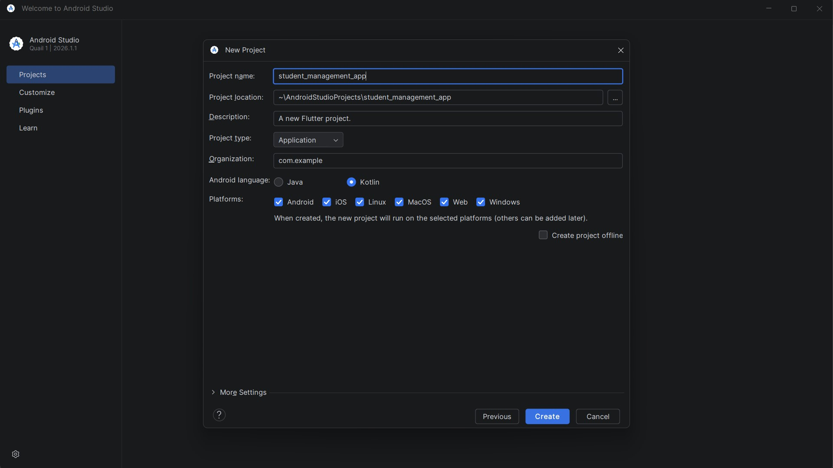
Project Configuration for Student Management App
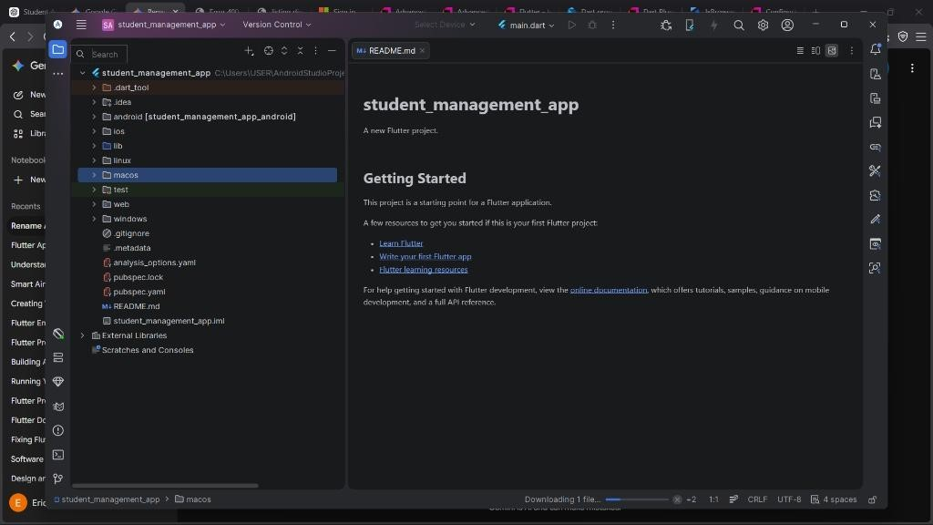
Project File Structure Organization
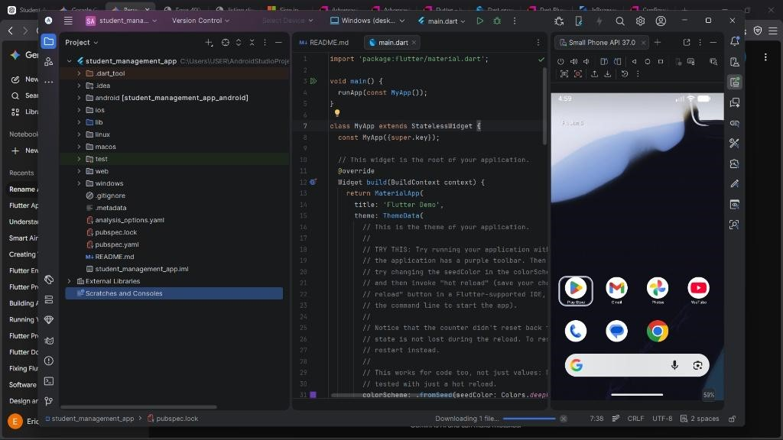
Initial Flutter Code Base
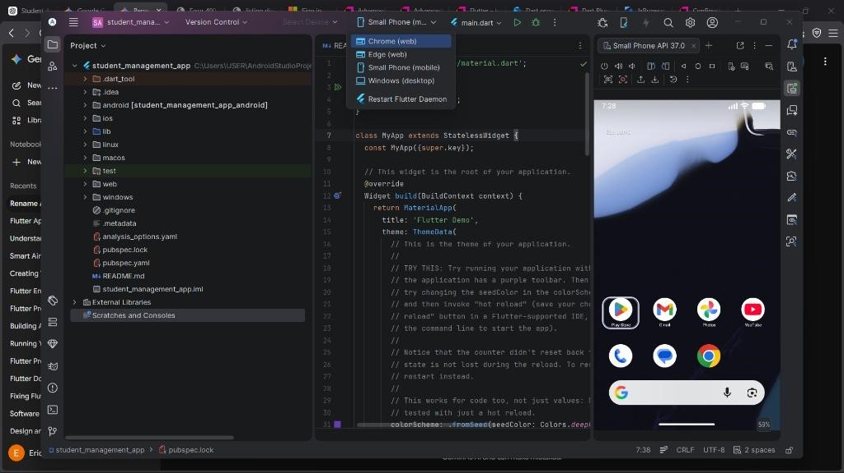
Device Selection for App Deployment
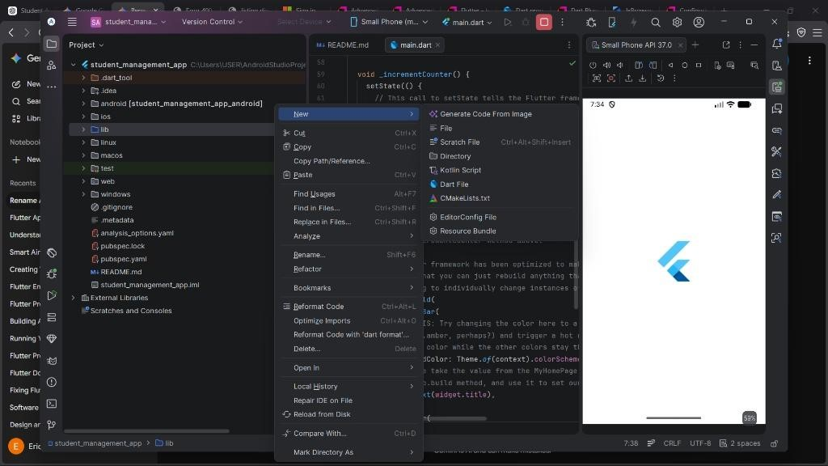
Flutter Application Launch State
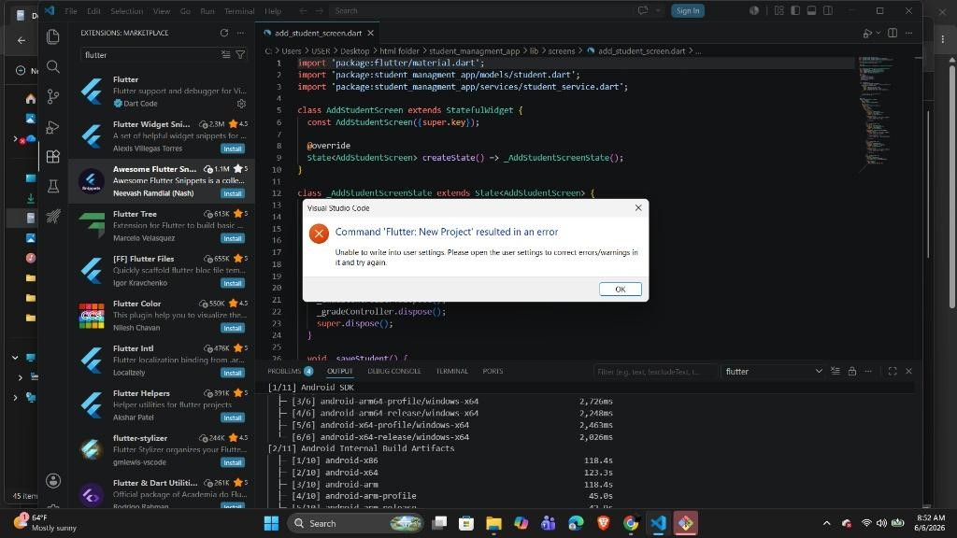
Handling Build Errors in VS Code
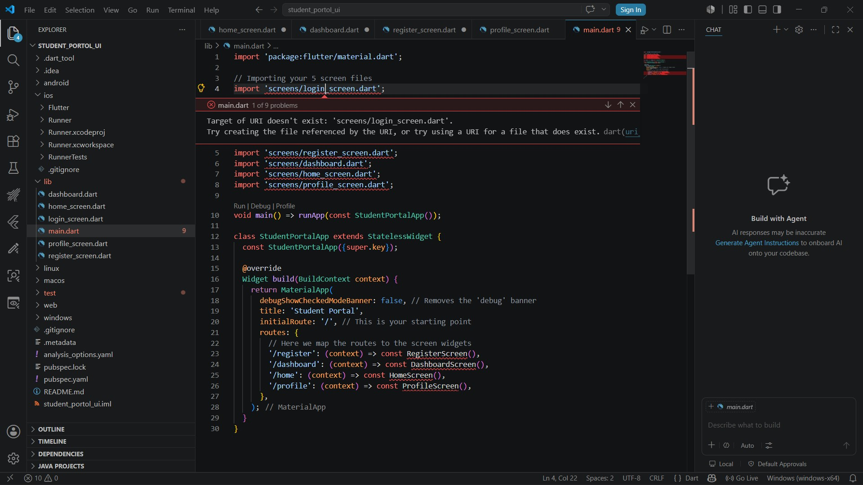
Routing Configuration in main.dart

